Supplementary Material

Growth dynamics and transcriptional responses of a Red Sea Prochlorococcus strain to varying temperatures

Abbrar Labban^{1,2}, Ahmed A. Shibl^{3,4}, Maria Ll. Calleja⁵, Pei-Ying Hong², and Xosé Anxelu G. Morán^{1,6*}

Gene ID  Table S1: Differentially expressed genes of Prochlorococcus RSP50, using transcriptomic data at 28˚C as a control for the differential expressions analysis at all other tested temperatures (22-30°C). | Annotation | log2  FoldChange | p-value | Padj | KEGG Pathway | Temperature (˚C)
BSR22_00004 | Uncharacterized protein | -4.7 | 0.0000389 | 0.000168856 | Uncharacterized protein | 22
BSR22_00382 | Uncharacterized protein | -4.5 | 0.000188254 | 0.000679642 | Uncharacterized protein | 22
BSR22_02114 | Uncharacterized protein | -3.8 | 2.61E-10 | 3.21E-09 | Uncharacterized protein | 22
BSR22_01973 | Uncharacterized protein | -3.4 | 7.24E-11 | 9.76E-10 | Uncharacterized protein | 22
BSR22_00384 | Uncharacterized protein | -3.4 | 2.48E-22 | 1.57E-20 | Uncharacterized protein | 22
BSR22_00330 | Uncharacterized protein | -3.3 | 0.000000518 | 0.00000338 | Uncharacterized protein | 22
BSR22_01755 | Uncharacterized protein | -3.3 | 0.015683176 | 0.033540808 | Uncharacterized protein | 22
BSR22_01698 | Possible ABC transporter component ATP-binding domain-containing protein | -3.3 | 9.99E-09 | 9.44E-08 | Environmental information processing/Membrane transport/ABC transporters | 22
BSR22_01520 | Uncharacterized protein | -3.2 | 0.0000291 | 0.000130047 | Uncharacterized protein | 22
BSR22_01564 | Uncharacterized protein | -3.1 | 0.008086619 | 0.019331447 | Uncharacterized protein | 22
BSR22_01981 | Uncharacterized protein | -3.1 | 1.31E-09 | 1.49E-08 | Uncharacterized protein | 22
BSR22_00119 | Chlorophyll a-b binding light harvesting protein PcbD | -3 | 5.11E-09 | 5.18E-08 | Energy metabolism/Photosynthesis/Photosynthetic electron transport/Collecting and transferring light energy to photosystems II and I | 22
BSR22_00383 | Uncharacterized protein | -3 | 1.83E-18 | 7.03E-17 | Uncharacterized protein | 22
BSR22_00331 | Uncharacterized protein | -3 | 3.33E-09 | 3.47E-08 | Uncharacterized protein | 22
BSR22_01567 | Uncharacterized protein | -2.8 | 0.020575768 | 0.042447647 | Uncharacterized protein | 22
BSR22_01599 | Multidrug efflux transporter | -2.8 | 6.09E-26 | 6.99E-24 | Transmembrane transporter activity | 22
BSR22_00687 | Putative uncharacterized protein | -2.7 | 0.001311862 | 0.003861885 | Uncharacterized protein | 22
BSR22_01167 | Putative TIR domain | -2.5 | 0.001338599 | 0.003934281 | Environmental Information Processing/Signal transduction/Toll-like receptor signaling pathway | 22
BSR22_01173 | Proline iminopeptidase | -2.5 | 1.58E-24 | 1.45E-22 | Amino acid metabolism/Arginine and proline metabolism/proline iminopeptidase | 22
BSR22_00029 | Uncharacterized protein | -2.5 | 0.040041327 | 0.075118025 | Uncharacterized protein | 22
BSR22_01972 | Uncharacterized protein | -2.4 | 6.95E-11 | 9.44E-10 | Uncharacterized protein | 22
BSR22_00024 | Uncharacterized protein | -2.3 | 8.83E-11 | 1.16E-09 | Uncharacterized protein | 22
BSR22_00338 | Fatty acid desaturase type 2 | -2.3 | 2.33E-19 | 9.71E-18 | Environmental Information Processing/Signal transduction/Two-component system | 22
BSR22_00370 | Uncharacterized protein | -2.3 | 4.28E-08 | 0.000000363 | Uncharacterized protein | 22
BSR22_02099 | Uncharacterized protein | -2.3 | 5.16E-10 | 6.14E-09 | Uncharacterized protein | 22
BSR22_00016 | Uncharacterized protein | -2.2 | 0.003482669 | 0.009177034 | Uncharacterized protein | 22
BSR22_02112 | Carboxyl-terminal processing protease | -2.1 | 2.04E-19 | 8.9E-18 | Peptidases and inhibitors | 22
BSR22_00339 | Uncharacterized protein | -2.1 | 5.91E-10 | 0.000000007 | Uncharacterized protein | 22
BSR22_01529 | Uncharacterized protein | -2 | 0.0000126 | 0.0000611 | Uncharacterized protein | 22
BSR22_00390 | Putative uncharacterized protein | -2 | 0.000983863 | 0.002973069 | Uncharacterized protein | 22
BSR22_01786 | Uncharacterized protein | -2 | 0.0000315 | 0.000139559 | Uncharacterized protein | 22
BSR22_01600 | Glyceraldehyde-3-phosphate dehydrogenase-erythrose-4-phosphate dehydrogenase | -2 | 2.32E-18 | 8.34E-17 | Carbohydrate metabolism/Glycolysis-Gluconeogenesis | 22
BSR22_01962 | Uncharacterized protein | -2 | 0.008411352 | 0.019956558 | Uncharacterized protein | 22
BSR22_02113 | Uncharacterized protein | -2 | 1.68E-08 | 0.000000153 | Uncharacterized protein | 22
BSR22_01957 | Uncharacterized protein | -2 | 0.00000935 | 0.0000467 | Uncharacterized protein | 22
BSR22_00455 | Uncharacterized protein | -1.9 | 0.014009561 | 0.0307707 | Uncharacterized protein | 22
BSR22_00443 | Uncharacterized protein | -1.9 | 0.000802529 | 0.002473678 | Uncharacterized protein | 22
BSR22_01046 | Putative uncharacterized protein | -1.9 | 0.0000171 | 0.0000801 | Uncharacterized protein | 22
BSR22_01555 | Possible PTS system Lactose-Cellobiose specif | -1.9 | 0.016847105 | 0.035392429 | Environmental Information Processing/Membrane transport/Phosphotransferase system (PTS) | 22
BSR22_01179 | Uncharacterized protein | -1.9 | 0.000000166 | 0.00000121 | Uncharacterized protein | 22
BSR22_01165 | Spectrin repeat-containing protein | -1.9 | 4.04E-22 | 2.47E-20 | Genetic Information Processing/Translation | 22
BSR22_01596 | Possible porin | -1.9 | 1.39E-09 | 1.57E-08 | Porin activity | 22
BSR22_00344 | Uncharacterized protein | -1.9 | 2.15E-14 | 4.98E-13 | Uncharacterized protein | 22
BSR22_00371 | Possible Hemagglutinin-neuraminidase | -1.9 | 5.06E-13 | 9.77E-12 | Virion attachment to host cell | 22
BSR22_00341 | Uncharacterized protein | -1.9 | 1.71E-11 | 2.59E-10 | Uncharacterized protein | 22
BSR22_00363 | Uncharacterized protein | -1.8 | 3.17E-08 | 0.000000276 | Uncharacterized protein | 22
BSR22_00337 | Uncharacterized protein | -1.8 | 2.11E-12 | 3.72E-11 | Uncharacterized protein | 22
BSR22_01525 | Uncharacterized protein | -1.8 | 2.63E-15 | 6.7E-14 | Uncharacterized protein | 22
BSR22_01362 | Photosystem I reaction center subunit XII | -1.8 | 4.47E-16 | 1.26E-14 | Energy metabolism/Photosynthesis/Photosystem I | 22
BSR22_00340 | Uncharacterized protein | -1.8 | 2.21E-13 | 4.61E-12 | Uncharacterized protein | 22
BSR22_02118 | hypothetical protein | -1.7 | 0.0000222 | 0.000101423 | Uncharacterized protein | 22
BSR22_01602 | Uncharacterized protein | -1.7 | 0.001924048 | 0.005428777 | Uncharacterized protein | 22
BSR22_00336 | Uncharacterized protein | -1.7 | 0.0000316 | 0.000139574 | Uncharacterized protein | 22
BSR22_00498 | Photosystem I subunit VIII (PsaI) | -1.7 | 0.0000402 | 0.000174243 | Energy metabolism/Photosynthesis/Photosystem I | 22
BSR22_01950 | Uncharacterized protein | -1.7 | 0.002436832 | 0.006640638 | Uncharacterized protein | 22
BSR22_02111 | Uncharacterized protein | -1.7 | 7.03E-18 | 2.39E-16 | Uncharacterized protein | 22
BSR22_01010 | Uncharacterized protein | -1.7 | 0.0000137 | 0.0000659 | Uncharacterized protein | 22
BSR22_01872 | Uncharacterized protein | -1.7 | 0.000120188 | 0.000455424 | Uncharacterized protein | 22
BSR22_01617 | Uncharacterized protein | -1.6 | 0.0000181 | 0.0000846 | Uncharacterized protein | 22
BSR22_01592 | Two component transcriptional regulator winged helix family | -1.6 | 0.000000215 | 0.00000154 | Environmental information processing/Signal transduction/Two-component system | 22
BSR22_01761 | Preprotein translocase subunit | -1.6 | 1.11E-10 | 1.44E-09 | Genetic information processing/Folding, sorting and degradation/Protein export | 22
BSR22_01075 | Beta phycoerythrin-like protein | -1.6 | 2.1E-18 | 7.86E-17 | Energy metabolism/Photosynthesis/Antenna proteins/Phycoerythrin (PE) | 22
BSR22_00154 | Lipid A core O-antigen ligase related enzyme | -1.6 | 0.00000011 | 0.000000837 | Glycan biosynthesis and metabolism/Lipopolysaccharide biosynthesis | 22
BSR22_01360 | Zn-dependent protease | -1.5 | 4.14E-08 | 0.000000353 | Peptidases and inhibitors | 22
BSR22_01490 | Uncharacterized protein | -1.5 | 6.35E-15 | 1.57E-13 | Uncharacterized protein | 22
BSR22_00120 | Flavodoxin | -1.5 | 0.000222116 | 0.000786411 | Energy metabolism/Photosynthesis/Photosynthetic electron transport/Iron-sulfur cluster assembly and Response to superoxide | 22
BSR22_00355 | Uncharacterized protein | -1.5 | 2.37E-09 | 2.62E-08 | Uncharacterized protein | 22
BSR22_01280 | Sec-independent protein translocase protein TatC | -1.5 | 1.43E-53 | 2.62E-50 | Genetic information processing/Folding, sorting and degradation/Protein export | 22
BSR22_01363 | Uncharacterized protein | -1.5 | 5.85E-19 | 2.33E-17 | Uncharacterized protein | 22
BSR22_00288 | Phosphoribosylaminoimidazole-succinocarboxamide synthase | -1.5 | 0.000000187 | 0.00000135 | Nucleotide metabolism/Purine metabolism | 22
BSR22_00125 | Putative helix-turn-helix protein copG family | -1.5 | 2.37E-14 | 5.44E-13 | Genetic information processing/Transcription factors | 22
BSR22_00002 | hypothetical protein | -1.4 | 0.0000264 | 0.000118952 | Hypothetical protein | 22
BSR22_01455 | Glutathione S-transferase N terminus | -1.4 | 0.000499075 | 0.001649196 | Metabolism of other amino acids/Glutathione metabolism | 22
BSR22_01411 | Uncharacterized protein | -1.4 | 0.00000115 | 0.00000699 | Uncharacterized protein | 22
BSR22_01830 | Possible SMC domain N terminal domain | -1.4 | 0.007957534 | 0.019077277 | Genetic information processing/DNA repair and recombination proteins | 22
BSR22_01828 | Probable ribonuclease II | -1.4 | 8.55E-09 | 8.24E-08 | Genetic information processing/Transfer RNA biogenesis | 22
BSR22_02056 | Uncharacterized protein | -1.4 | 4.31E-17 | 1.36E-15 | Uncharacterized protein | 22
BSR22_01951 | Uncharacterized protein | -1.4 | 1.11E-16 | 3.28E-15 | Uncharacterized protein | 22
BSR22_01385 | Glycosyltransferases involved in cell wall biogenesis | -1.4 | 0.014302352 | 0.031189672 | Glycosyltransferases | 22
BSR22_01701 | Possible S1 RNA binding domain-containing protein | -1.4 | 5.27E-08 | 0.000000433 | Genetic Information Processing/Translation/Ribosome | 22
BSR22_02110 | Uncharacterized protein | -1.4 | 5.91E-18 | 2.05E-16 | Uncharacterized protein | 22
BSR22_01276 | Prolipoprotein diacylglyceryl transferase | -1.4 | 3.25E-23 | 2.48E-21 | Unclassified: metabolism/Enzymes with EC numbers | 22
BSR22_01808 | Possible cysteine desulfurase (Class-V aminotransferase family) | -1.4 | 0.000000303 | 0.00000211 | Cofactors and vitamins metabolism/Thiamine (Vitamin B1) metabolism | 22
BSR22_00826 | Putative bacterioferritin comigratory (BCP) protein | -1.4 | 0.00000294 | 0.0000165 | Oxidoreductases/Response to oxidative stress | 22
BSR22_01076 | Chromophore lyase CpcS-CpeS | -1.4 | 1.93E-10 | 2.44E-09 | Lyase activity | 22
BSR22_01940 | Uncharacterized protein | -1.3 | 7.47E-08 | 0.00000059 | Uncharacterized protein | 22
BSR22_01777 | Uncharacterized protein | -1.3 | 0.012383583 | 0.027764658 | Uncharacterized protein | 22
BSR22_00067 | Uncharacterized protein | -1.3 | 0.000365892 | 0.001240382 | Uncharacterized protein | 22
BSR22_01933 | Possible Legume lectins alpha domain-containing protein | -1.3 | 0.009681589 | 0.022504479 | Carbohydrate binding | 22
BSR22_01699 | Rieske iron-sulfur protein 2Fe-2S subunit | -1.3 | 3.5E-30 | 5.83E-28 | Energy metabolism/Photosynthesis/Photosynthetic electron transport/Mediates electron transfer from iron-sulfur centers of photosystem I (PSI-C subunit) to ferredoxin NADP reductase | 22
BSR22_00609 | Glutamine--fructose-6-phosphate aminotransferase isomerizing | -1.3 | 2.83E-39 | 1.04E-36 | Carbohydrate metabolism/Amino sugar and nucleotide sugar metabolism | 22
BSR22_01478 | Uncharacterized protein | -1.3 | 0.003570306 | 0.009367583 | Uncharacterized protein | 22
BSR22_00911 | Uncharacterized protein | -1.3 | 8.31E-11 | 1.1E-09 | Uncharacterized protein | 22
BSR22_02059 | Possible UvrD-REP helicase subunit B | -1.3 | 0.001273099 | 0.003753799 | Genetic information processing/DNA repair and recombination proteins | 22
BSR22_00164 | Chain length determinant protein | -1.3 | 1.01E-25 | 1.02E-23 | Glycan biosynthesis and metabolism/Lipopolysaccharide biosynthesis in bacterial outer membrane biogenesis | 22
BSR22_00587 | 1516-dihydrobiliverdin;ferredoxin oxidoreductase | -1.3 | 2.42E-10 | 3.01E-09 | Metabolism of cofactors and vitamins/Porphyrin metabolism | 22
BSR22_01906 | Uncharacterized protein | -1.3 | 0.000000747 | 0.00000474 | Uncharacterized protein | 22
BSR22_01684 | Uncharacterized protein | -1.3 | 0.000000712 | 0.00000453 | Uncharacterized protein | 22
BSR22_01899 | Putative ATP synthase protein 8 | -1.3 | 0.000000313 | 0.00000217 | Energy metabolism/Oxidative phosphorylation/ATP synthesis | 22
BSR22_01621 | Uncharacterized protein | -1.3 | 0.006921107 | 0.016924414 | Uncharacterized protein | 22
BSR22_00170 | Polysaccharide deacetylase Est4B | -1.3 | 1.68E-13 | 3.55E-12 | Carbohydrate metabolism/Deacetylation | 22
BSR22_00565 | Putative uncharacterized protein | -1.3 | 1.18E-08 | 0.00000011 | Uncharacterized protein | 22
BSR22_00042 | Uncharacterized protein | -1.3 | 0.003681122 | 0.009630781 | Uncharacterized protein | 22
BSR22_00499 | Possible Annexin | -1.3 | 0.0107776 | 0.024584724 | Lipid-binding proteins | 22
BSR22_00895 | Inactive metal-dependent protease-like protein putative molecular chaperone | -1.3 | 1.44E-11 | 2.22E-10 | Genetic information processing/Transfer RNA biogenesis | 22
BSR22_00157 | Galactosyl-1-phosphate transferase | -1.3 | 0.00000255 | 0.0000145 | Other carbohydrate metabolism/Galactose metabolism | 22
BSR22_01598 | Putative chromate transporter | -1.2 | 2.81E-09 | 3.02E-08 | Signaling and cellular processes/Transporters Inhibition of sulfate transport | 22
BSR22_00919 | Uncharacterized protein | -1.2 | 0.014048909 | 0.030820215 | Uncharacterized protein | 22
BSR22_00182 | Uncharacterized protein | -1.2 | 2.29E-11 | 3.34E-10 | Uncharacterized protein | 22
BSR22_01335 | Putative arsenate reductase | -1.2 | 0.006222181 | 0.015358654 | Oxidoreductases/enzymes with EC numbers | 22
BSR22_01662 | Possible coat protein-like protein | -1.2 | 0.0000145 | 0.0000692 | Unclassified | 22
BSR22_01763 | Predicted permease | -1.2 | 0.0000164 | 0.0000772 | Signaling and cellular processes/Transporters | 22
BSR22_01281 | Uncharacterized protein | -1.2 | 7.12E-33 | 1.63E-30 | Uncharacterized protein | 22
BSR22_01903 | Possible Josephin | -1.2 | 2.6E-09 | 2.84E-08 | Peptidases and inhibitors | 22
BSR22_00938 | Uncharacterized protein | -1.2 | 0.001211725 | 0.003578588 | Uncharacterized protein | 22
BSR22_00400 | Uncharacterized protein | -1.2 | 6.06E-15 | 1.52E-13 | Uncharacterized protein | 22
BSR22_00169 | hypothetical protein | -1.2 | 0.00000795 | 0.0000407 | Uncharacterized protein | 22
BSR22_02100 | Uncharacterized protein | -1.2 | 2.48E-11 | 3.58E-10 | Uncharacterized protein | 22
BSR22_00939 | Endoribonuclease YbeY | -1.2 | 0.000887194 | 0.002702848 | Genetic information processing/Ribosome biogenesis (Heat shock protein) | 22
BSR22_01873 | Uncharacterized protein | -1.2 | 0.0002688 | 0.000935443 | Uncharacterized protein | 22
BSR22_01436 | Putative uncharacterized protein | -1.2 | 3.21E-08 | 0.000000278 | Uncharacterized protein | 22
BSR22_00631 | Adenosylhomocysteinase | 1.2 | 1.14E-21 | 6.73E-20 | Amino acid metabolism/Cysteine and methionine metabolism | 22
BSR22_00256 | ATP-dependent Clp protease proteolytic subunit | 1.2 | 8.22E-11 | 1.1E-09 | Genetic information processing/Chaperones and folding catalysts (Heat shock protein) | 22
BSR22_01065 | Putative rubredoxin | 1.2 | 7.91E-23 | 5.58E-21 | Redox and ROS detoxification | 22
BSR22_00595 | Phosphorylase | 1.2 | 4.14E-23 | 3.04E-21 | Carbohydrate metabolism/Starch and sucrose metabolism | 22
BSR22_01930 | Possible Photosystem II reaction centre N prot | 1.2 | 0.0000781 | 0.000317452 | Energy metabolism/Photosynthesis/Photosystem II/Repairing PSII reaction centers during photoinhibition | 22
BSR22_01523 | Uncharacterized protein | 1.2 | 6.95E-12 | 1.13E-10 | Uncharacterized protein | 22
BSR22_02078 | Uncharacterized protein | 1.2 | 1.18E-13 | 2.55E-12 | Uncharacterized protein | 22
BSR22_00136 | ATPase | 1.2 | 5.96E-24 | 4.97E-22 | Energy metabolism/Oxidative phosphorylation/ATP synthesis | 22
BSR22_00764 | Uncharacterized protein | 1.3 | 1.05E-16 | 3.17E-15 | Uncharacterized protein | 22
BSR22_01261 | Cytochrome c oxidase subunit 2 | 1.3 | 2.96E-40 | 1.36E-37 | Energy metabolism/Oxidative phosphorylation/ATP synthesis | 22
BSR22_01260 | Cytochrome c oxidase subunit I | 1.3 | 3.62E-34 | 9.47E-32 | Energy metabolism/Oxidative phosphorylation/ATP synthesis | 22
BSR22_01104 | PDZ domain protein | 1.3 | 3.57E-27 | 4.67E-25 | Signaling and cellular processes/Organizing transmembrane proteins/Protein quality control during stress response | 22
BSR22_01978 | Cobalamin synthesis protein-P47K | 1.3 | 2.41E-22 | 1.57E-20 | Unclassified cofactor | 22C
BSR22_00709 | Multidrug efflux transporter MFS family | 1.4 | 7.13E-32 | 1.31E-29 | Signaling and cellular processes/Transporters | 22
BSR22_01707 | Uncharacterized protein | 1.4 | 0.00000466 | 0.0000249 | Uncharacterized protein | 22
BSR22_01146 | Plastoquinol terminal oxidase | 1.5 | 1.77E-09 | 1.98E-08 | Energy metabolism/Photosynthesis/Photosynthetic electron transport/extracting electrons between PSII and PSI and combine them with protons and oxygen to produce water | 22
BSR22_00079 | EF-1 guanine nucleotide exchange domain-like protein | 1.5 | 8.66E-10 | 0.00000001 | Genetic information processing/Membrane trafficking | 22
BSR22_00988 | Uncharacterized protein | 1.5 | 1.34E-15 | 3.55E-14 | Uncharacterized protein | 22
BSR22_01341 | Transaldolase | 1.5 | 6.99E-26 | 7.54E-24 | Carbohydrate metabolism/Pentose phosphate pathway | 22
BSR22_02094 | Glycerol kinase | 1.5 | 1.06E-36 | 3.25E-34 | Lipid metabolism/Glycerolipid metabolism | 22
BSR22_01613 | Possible COMC family | 1.6 | 0.00000212 | 0.0000122 | Unclassified | 22
BSR22_00918 | Citrate synthase | 1.6 | 3.82E-32 | 7.79E-30 | Carbohydrate metabolism/Tricarboxylic acid cycle | 22
BSR22_00017 | Uncharacterized protein | 1.6 | 5.1E-20 | 2.46E-18 | Uncharacterized protein | 22
BSR22_01366 | Light-independent protochlorophyllide reductase subunit B | 1.6 | 2.77E-16 | 7.95E-15 | Cofactors and vitamins metabolism/Porphyrin and chlorophyll metabolism | 22
BSR22_02080 | Possible porin | 1.6 | 6.38E-21 | 3.54E-19 | Porin activity | 22
BSR22_02082 | Possible porin | 1.7 | 5.83E-20 | 2.68E-18 | Porin activity | 22
BSR22_00315 | Short-chain dehydrogenase-reductase (SDR) superfamily | 1.7 | 2.27E-44 | 1.38E-41 | Cofactors and vitamins metabolism/Porphyrin and chlorophyll metabolism | 22
BSR22_01305 | Band 7 protein | 1.8 | 3.13E-28 | 4.42E-26 | Unclassified | 22
BSR22_01367 | Light-independent protochlorophyllide reductase subunit N | 1.9 | 1.9E-24 | 1.66E-22 | Cofactors and vitamins metabolism/Porphyrin and chlorophyll metabolism | 22
BSR22_02103 | hypothetical protein | 2.1 | 1.47E-28 | 2.24E-26 | Hypothetical protein | 22
BSR22_00312 | Predicted membrane protein | 2.6 | 1.36E-26 | 1.66E-24 | Unclassified | 22
BSR22_01599 | Multidrug efflux transporter | -3 | 2.22E-29 | 6.8E-27 | Transmembrane transporter activity | 24
BSR22_01596 | Possible porin | -2.6 | 1.03E-16 | 1.05E-14 | Porin activity | 24
BSR22_01600 | Glyceraldehyde-3-phosphate dehydrogenase-erythrose-4-phosphate dehydrogenase | -2 | 3.14E-19 | 4.43E-17 | Carbohydrate metabolism/Glycolysis-Gluconeogenesis | 24
BSR22_01973 | Uncharacterized protein | -1.8 | 0.000231343 | 0.001675673 | Uncharacterized protein | 24
BSR22_00384 | Uncharacterized protein | -1.6 | 0.00000527 | 0.00007 | Uncharacterized protein | 24
BSR22_02112 | Carboxyl-terminal processing protease | -1.6 | 9.51E-12 | 4.15E-10 | Peptidases and inhibitors | 24
BSR22_02114 | Uncharacterized protein | -1.5 | 0.006070165 | 0.024360356 | Uncharacterized protein | 24
BSR22_01592 | Two component transcriptional regulator winged helix family | -1.4 | 0.00000104 | 0.0000179 | Environmental information processing/Signal transduction/Two-component system | 24
BSR22_02099 | Uncharacterized protein | -1.4 | 0.0000216 | 0.000232766 | Uncharacterized protein | 24
BSR22_00001 | Tryptophan-rich Synechocystis specie protein | -1.4 | 3.66E-15 | 2.8E-13 | Signaling and cellular processes/Transporters | 24
BSR22_02100 | Uncharacterized protein | -1.3 | 1.1E-14 | 7.46E-13 | Uncharacterized protein | 24
BSR22_01972 | Uncharacterized protein | -1.3 | 0.000461951 | 0.002805356 | Uncharacterized protein | 24
BSR22_01525 | Uncharacterized protein | -1.2 | 1.78E-08 | 0.000000442 | Uncharacterized protein | 24
BSR22_02113 | Uncharacterized protein | -1.2 | 0.00042268 | 0.002627779 | Uncharacterized protein | 24
BSR22_00662 | 4-hydroxy-tetrahydrodipicolinate synthase | -1.2 | 3.44E-15 | 2.74E-13 | Amino acid metabolism/Lysine biosynthesis | 24
BSR22_00383 | Uncharacterized protein | -1.2 | 0.000202376 | 0.001529799 | Uncharacterized protein | 24
BSR22_01173 | Proline iminopeptidase | -1.2 | 0.00000133 | 0.000022 | Amino acid metabolism/Arginine and proline metabolism/proline iminopeptidase | 24
BSR22_00590 | Isocitrate dehydrogenase NADP | 1.2 | 1.58E-16 | 1.52E-14 | Carbohydrate metabolism/Tricarboxylic acid cycle | 24
BSR22_00381 | Putative agmatine ureohydrolase | 1.2 | 1.17E-12 | 6.51E-11 | Amino acid metabolism/Arginine and proline metabolism | 24
BSR22_00335 | Putative Type I restriction modification DNA specificity domain-containing protein | 1.2 | 0.000451237 | 0.002749395 | Signaling and cellular processes/Prokaryotic Defense System | 24
BSR22_01209 | Light repressed protein A-like protein | 1.2 | 1.15E-09 | 3.56E-08 | Genetic information processing/Ribosome biogenesis | 24
BSR22_01158 | Sec-independent protein translocase protein TatA | 1.2 | 9.81E-15 | 6.92E-13 | Genetic information processing/Folding, sorting and degradation/Protein export | 24
BSR22_01146 | Plastoquinol terminal oxidase | 1.2 | 0.000000335 | 0.00000614 | Energy metabolism/Photosynthesis/Photosynthetic electron transport/extracting electrons between PSII and PSI and combine them with protons and oxygen to produce water | 24
BSR22_01341 | Transaldolase | 1.3 | 2.81E-18 | 3.44E-16 | Carbohydrate metabolism/Pentose phosphate pathway | 24
BSR22_01182 | Uncharacterized protein | 1.3 | 5.84E-09 | 0.000000155 | Uncharacterized protein | 24
BSR22_00918 | Citrate synthase | 1.3 | 3.01E-22 | 5.52E-20 | Carbohydrate metabolism/Tricarboxylic acid cycle | 24
BSR22_01260 | Cytochrome c oxidase subunit I | 1.3 | 1.92E-33 | 1.76E-30 | Energy metabolism/Oxidative phosphorylation/ATP synthesis | 24
BSR22_00088 | Photosystem I assembly protein Ycf4 | 1.3 | 6.23E-29 | 1.63E-26 | Energy metabolism/Photosynthesis/Photosystem I | 24
BSR22_01539 | Putative uncharacterized protein | 1.3 | 0.000336357 | 0.002243195 | Uncharacterized protein | 24
BSR22_01613 | Possible COMC family | 1.3 | 0.0000483 | 0.000463596 | Unclassified | 24
BSR22_00388 | Uncharacterized protein | 1.4 | 1.15E-11 | 4.89E-10 | Uncharacterized protein | 24
BSR22_01715 | Putative urea ABC transporter substrate binding protein | 1.4 | 6.23E-15 | 4.57E-13 | Environmental information processing/Membrane transport/ABC transporters | 24
BSR22_00988 | Uncharacterized protein | 1.4 | 9.41E-14 | 5.76E-12 | Uncharacterized protein | 24
BSR22_00439 | Fumarate lyase;Adenylosuccinate lyase | 1.4 | 3.65E-21 | 5.58E-19 | Nucleotide metabolism/Purine metabolism | 24
BSR22_00111 | Porin-like protein | 1.4 | 0.001262125 | 0.006651544 | Porin activity | 24
BSR22_01544 | Possible DUP family | 1.5 | 0.001809443 | 0.008849382 | Unclassified | 24
BSR22_00117 | Uncharacterized protein | 1.6 | 3.79E-22 | 6.32E-20 | Uncharacterized protein | 24
BSR22_01261 | Cytochrome c oxidase subunit 2 | 1.7 | 3.99E-70 | 7.31E-67 | Energy metabolism/Oxidative phosphorylation/ATP synthesis | 24
BSR22_01451 | Putative uncharacterized protein | 1.8 | 0.006135315 | 0.024461884 | Uncharacterized protein | 24
BSR22_01931 | Uncharacterized protein | 1.8 | 5.57E-08 | 0.00000122 | Uncharacterized protein | 24
BSR22_01930 | Possible Photosystem II reaction centre N prot | 1.8 | 2.63E-09 | 7.53E-08 | Energy metabolism/Photosynthesis/Photosystem II/Repairing PSII reaction centers during photoinhibition | 24
BSR22_00314 | NAD-dependent DNA ligase N-terminus | 1.9 | 0.00000492 | 0.0000661 | Genetic information processing/DNA Replication and repair | 24
BSR22_00328 | Uncharacterized protein | 2.1 | 0.00283936 | 0.012985999 | Uncharacterized protein | 24
BSR22_01367 | Light-independent protochlorophyllide reductase subunit N | 2.2 | 1.32E-31 | 8.07E-29 | Cofactors and vitamins metabolism/Porphyrin and chlorophyll metabolism | 24
BSR22_01366 | Light-independent protochlorophyllide reductase subunit B | 2.2 | 1.93E-30 | 7.08E-28 | Cofactors and vitamins metabolism/Porphyrin and chlorophyll metabolism | 24
BSR22_01472 | Uncharacterized protein | 2.4 | 7.12E-28 | 1.63E-25 | Uncharacterized protein | 24
BSR22_00079 | EF-1 guanine nucleotide exchange domain-like protein | 2.5 | 6.89E-24 | 1.4E-21 | Genetic information processing/Membrane trafficking | 24
BSR22_02114 | Uncharacterized protein | -2.1 | 0.000148226 | 0.002537235 | Uncharacterized protein | 26
BSR22_00331 | Uncharacterized protein | -2.1 | 0.000015 | 0.000455142 | Uncharacterized protein | 26
BSR22_01564 | Uncharacterized protein | -2 | 0.017692909 | NA | Uncharacterized protein | 26
BSR22_01774 | Uncharacterized protein | -1.7 | 0.024652093 | NA | Uncharacterized protein | 26
BSR22_00384 | Uncharacterized protein | -1.5 | 0.0000168 | 0.000478805 | Uncharacterized protein | 26
BSR22_00498 | Photosystem I subunit VIII (PsaI) | -1.4 | 0.000739749 | 0.007674362 | Energy metabolism/Photosynthesis/Photosystem I | 26
BSR22_00119 | Chlorophyll a-b binding light harvesting protein PcbD | -1.4 | 0.007609926 | 0.041235159 | Energy metabolism/Photosynthesis/Photosynthetic electron transport/Collecting and transferring light energy to photosystems II and I | 26
BSR22_01165 | Spectrin repeat-containing protein | -1.4 | 6.26E-13 | 1.1E-09 | Genetic Information Processing/Translation | 26
BSR22_00330 | Uncharacterized protein | -1.4 | 0.005717678 | 0.03415101 | Uncharacterized protein | 26
BSR22_00370 | Uncharacterized protein | -1.3 | 0.000777414 | 0.00787243 | Uncharacterized protein | 26
BSR22_01698 | Possible ABC transporter component ATP-binding domain-containing protein | -1.3 | 0.001940459 | 0.015201416 | Environmental information processing/Membrane transport/ABC transporters | 26
BSR22_00383 | Uncharacterized protein | -1.3 | 0.0000669 | 0.001387326 | Uncharacterized protein | 26
BSR22_01624 | Uncharacterized protein | -1.3 | 0.005055699 | 0.031488444 | Uncharacterized protein | 26
BSR22_01362 | Photosystem I reaction center subunit XII | -1.3 | 4.92E-10 | 0.000000124 | Energy metabolism/Photosynthesis/Photosystem I | 26
BSR22_01981 | Uncharacterized protein | -1.2 | 0.001917986 | 0.015154667 | Uncharacterized protein | 26
BSR22_01873 | Uncharacterized protein | -1.2 | 0.0000709 | 0.001435772 | Uncharacterized protein | 26
BSR22_00344 | Uncharacterized protein | -1.2 | 0.000000645 | 0.0000598 | Uncharacterized protein | 26
BSR22_01761 | Preprotein translocase subunit | -1.2 | 0.000000953 | 0.000073 | Genetic Information Processing/Folding, sorting and degradation/Protein export | 26
BSR22_01173 | Proline iminopeptidase | -1.2 | 0.00000107 | 0.0000756 | Amino acid metabolism/Arginine and proline metabolism/proline iminopeptidase | 26
BSR22_01895 | Uncharacterized protein | -1.2 | 5.75E-08 | 0.00000779 | Uncharacterized protein | 26
BSR22_00938 | Uncharacterized protein | -1.2 | 0.000801402 | 0.007932978 | Uncharacterized protein | 26
BSR22_02099 | Uncharacterized protein | -1.2 | 0.000337335 | 0.004276151 | Uncharacterized protein | 26
BSR22_01599 | Multidrug efflux transporter | -3.1 | 1.51E-30 | 2.76E-27 | Transmembrane transporter activity | 30
BSR22_01596 | Possible porin | -2.7 | 1.01E-18 | 2.31E-16 | Porin activity | 30
BSR22_00717 | NAD binding site;D-amino acid oxidase | -2.7 | 7.89E-20 | 2.07E-17 | Cofactors and vitamins metabolism/Thiamine metabolism (Vitamin B1) | 30
BSR22_00119 | Chlorophyll a-b binding light harvesting protein PcbD | -2.3 | 0.00000692 | 0.0000707 | Energy metabolism/Photosynthesis/Photosynthetic electron transport/Collecting and transferring light energy to photosystems II and I | 30
BSR22_01374 | Carboxysome shell protein CsoS2 | -2.1 | 5.46E-14 | 4.72E-12 | Energy metabolism/Carbon fixation | 30
BSR22_01185 | Uncharacterized protein | -1.9 | 1.06E-17 | 1.62E-15 | Uncharacterized protein | 30
BSR22_01600 | Glyceraldehyde-3-phosphate dehydrogenase-erythrose-4-phosphate dehydrogenase | -1.9 | 3.66E-16 | 4.48E-14 | Carbohydrate metabolism/Glycolysis-Gluconeogenesis | 30
BSR22_00407 | 10 kDa chaperonin | -1.8 | 1.56E-18 | 3.18E-16 | Genetic information processing/Chaperones and folding catalysts (Heat shock protein) | 30
BSR22_00718 | Chaperone protein DnaK | -1.8 | 0.000000173 | 0.00000302 | Genetic information processing/Folding, sorting and degradation/RNA degradation (Heat shock protein) | 30
BSR22_01981 | Uncharacterized protein | -1.6 | 0.000094 | 0.000631318 | Uncharacterized protein | 30
BSR22_00111 | Porin-like protein | -1.5 | 0.000717232 | 0.003466266 | Porin activity | 30
BSR22_01698 | Possible ABC transporter component ATP-binding domain-containing protein | -1.5 | 0.0004165 | 0.002226997 | Environmental information processing/Membrane transport/ABC transporters | 30
BSR22_01375 | Carboxysome shell protein CsoS3 | -1.5 | 6.58E-15 | 7.1E-13 | Energy metabolism/Carbon fixation | 30
BSR22_01146 | Plastoquinol terminal oxidase | -1.4 | 3.89E-09 | 0.000000127 | Energy metabolism/Photosynthesis/Photosynthetic electron transport/extracting electrons between PSII and PSI and combine them with protons and oxygen to produce water | 30
BSR22_01592 | Two component transcriptional regulator winged helix family | -1.4 | 0.00000146 | 0.0000183 | Environmental information processing/Signal transduction/Two-component system | 30
BSR22_00970 | Putative sodium-dependent bicarbonate transporter | -1.4 | 4.53E-18 | 7.56E-16 | Signaling and cellular processes/Transporters | 30
BSR22_00969 | Uncharacterized protein | -1.4 | 1.22E-20 | 4.48E-18 | Uncharacterized protein | 30
BSR22_01172 | Putative uncharacterized protein | -1.3 | 2.06E-10 | 9.23E-09 | Uncharacterized protein | 30
BSR22_00020 | Uncharacterized protein | -1.3 | 0.000000869 | 0.0000115 | Uncharacterized protein | 30
BSR22_00406 | 60 kDa chaperonin 2 | -1.3 | 1.99E-14 | 1.92E-12 | Genetic information processing/Chaperones and folding catalysts (Heat shock protein) | 30
BSR22_00857 | RibD-ribG C-terminal domain-containing protein | -1.3 | 2.73E-14 | 2.5E-12 | Metabolism of cofactors and vitamins/vitamin B2 metabolism | 30
BSR22_00330 | Uncharacterized protein | -1.3 | 0.010213298 | 0.032019127 | Uncharacterized protein | 30
BSR22_00019 | Uncharacterized protein | -1.2 | 0.0000109 | 0.000104177 | Uncharacterized protein | 30
BSR22_01598 | Putative chromate transporter | -1.2 | 8.5E-10 | 3.25E-08 | Signaling and cellular processes/Transporters inhibition of sulfate transport | 30
BSR22_01873 | Uncharacterized protein | -1.2 | 0.000105935 | 0.000693873 | Uncharacterized protein | 30
BSR22_02099 | Uncharacterized protein | -1.2 | 0.000297228 | 0.001665733 | Uncharacterized protein | 30
BSR22_01525 | Uncharacterized protein | -1.2 | 0.000000219 | 0.00000372 | Uncharacterized protein | 30
BSR22_00001 | Tryptophan-rich Synechocystis specie protein | -1.2 | 2.76E-11 | 1.53E-09 | Signaling and cellular processes/Transporters | 30
BSR22_01931 | Uncharacterized protein | 1.2 | 0.000519085 | 0.002681695 | Uncharacterized protein | 30
BSR22_01544 | Possible DUP family | 1.2 | 0.012567804 | 0.03766234 | Unclassified | 30
BSR22_01870 | Uncharacterized protein | 1.2 | 0.003094262 | 0.012048569 | Uncharacterized protein | 30
BSR22_01368 | Uncharacterized protein | 1.2 | 5.66E-14 | 4.72E-12 | Uncharacterized protein | 30
BSR22_00952 | Phosphoglycerate kinase | 1.2 | 0.000000164 | 0.00000289 | Carbohydrate metabolism/Glycolysis-Gluconeogenesis | 30
BSR22_02063 | Pyridoxine 5'-phosphate synthase | 1.3 | 2.3E-27 | 2.11E-24 | Metabolism of cofactors and vitamins/Vitamin B6 metabolism | 30
BSR22_01163 | Uncharacterized protein | 1.3 | 3.05E-08 | 0.000000756 | Uncharacterized protein | 30
BSR22_01258 | Uncharacterized protein | 1.4 | 8.25E-15 | 8.41E-13 | Uncharacterized protein | 30
BSR22_01822 | Uncharacterized protein | 1.4 | 1.56E-09 | 5.63E-08 | Uncharacterized protein | 30
BSR22_01552 | Uncharacterized protein | 1.4 | 0.00523638 | 0.018539615 | Uncharacterized protein | 30
BSR22_00839 | Uncharacterized protein | 1.5 | 0.000000134 | 0.00000254 | Uncharacterized protein | 30
BSR22_01608 | Uncharacterized protein | 1.5 | 9.49E-24 | 4.35E-21 | Uncharacterized protein | 30
BSR22_00027 | Uncharacterized protein | 1.6 | 9.92E-08 | 0.00000196 | Uncharacterized protein | 30
BSR22_00883 | Possible Signal peptide binding domain-containing protein | 1.6 | 0.000559787 | 0.002820465 | Genetic Information Processing/Folding, sorting and degradation/Protein export | 30
BSR22_01930 | Possible Photosystem II reaction centre N prot | 1.6 | 0.000000122 | 0.00000233 | Energy metabolism/Photosynthesis/Photosystem II/Repairing PSII reaction centers during photoinhibition | 30
BSR22_00029 | Uncharacterized protein | 2.2 | 0.001411092 | 0.006266206 | Uncharacterized protein | 30
BSR22_00028 | Uncharacterized protein | 2.2 | 0.000000549 | 0.00000781 | Uncharacterized protein | 30
BSR22_00055 | Uncharacterized protein | 2.4 | 1.88E-10 | 8.62E-09 | Uncharacterized protein | 30

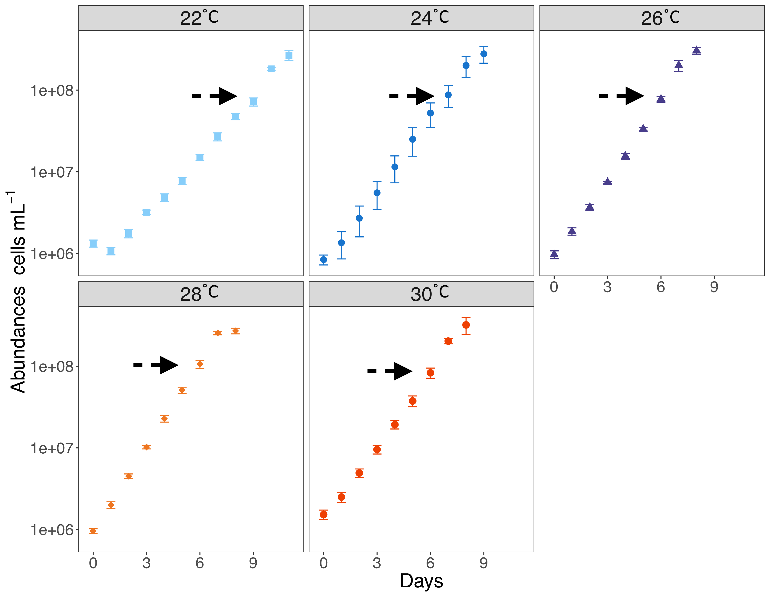
(Cells mL ⁻¹)

Fig. S1: Temporal changes in Prochlorococcus RSP50 abundance at the 5 different temperatures. Samples for flow cytometry were collected every day for 8 to 11 days depending on the incubation temperature (i.e., the lower the temperature, the longer the duration of the experiment). Samples for heterotrophic bacteria, Chl a, DOC, FDOM, and inorganic nutrients were collected at initial time (day 0), final time (day 8, 9 or 11) and during the exponential growth phase when RNA samples were collected for sequencing, indicated by the arrows on the graph.

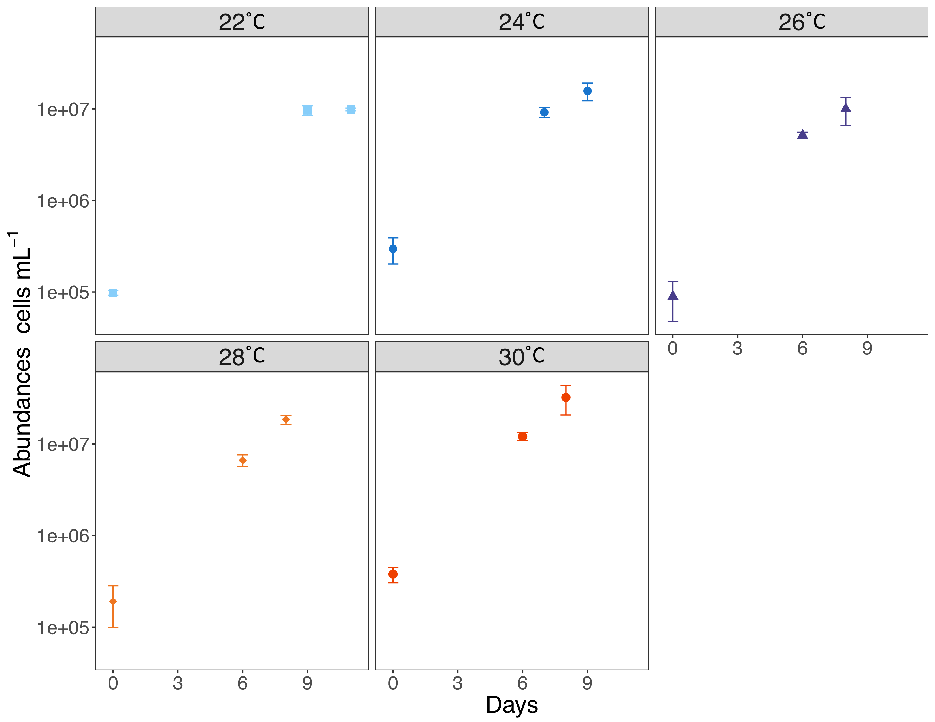
(Cells mL ⁻¹)

Fig. S2: Heterotrophic bacterial abundance in the Prochlorococcus RSP50 cultures at the 5 different temperatures. Note that contrary to the cyanobacteria, which were sampled daily, samples for heterotrophic bacteria were collected only 3 times during the incubations.

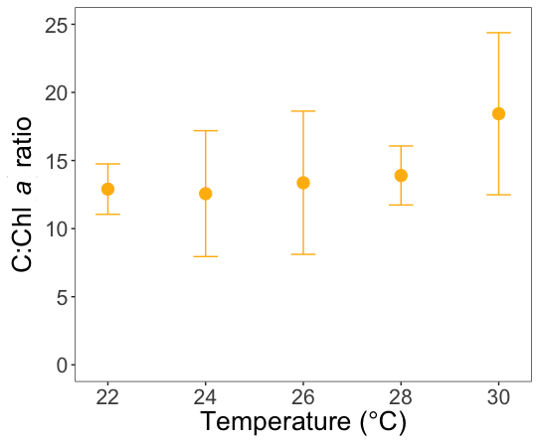

Fig. S3: Mean carbon (µg L⁻¹) to chlorophyll a (µg L⁻¹) ratio of Prochlorococcus RSP50 vs. incubation temperature. Error bars represent standard deviations.

Fig. S4: Percent changes at the end of the incubations (final vs. initial values) at the 5 different temperatures treatments of net DOC concentrations (A) and the protein to humic fluorescent ratio (B). PROT/HUM was calculated as the sum of fluorescence emitted by the protein-like components (C2 + C4) divided by that of the humic-like components (C1+ C3). Changes are calculated as [(Final-Initial)/Initial x 100]. Error bars represent standard deviation.

Fig. S5: Colored dissolved organic matter (CDOM) absorbance spectra of all cultures normalized to DOC concentration at the beginning (A) and the end (B) of the incubations at the 5 different temperatures. Measurements of 4 replicates are shown.

Fig. S6: Fluorescent dissolved organic matter (FDOM) changes observed in the cultures at the 5 different temperatures. Left panels (A, B, C, D, E) display changes in the fluorescent signal of all components with time. Right panels (F, G, H, I, J) display changes in the total fluorescent signal and the relative abundance of each component with time.

Fig. S7: Relative abundance of the protein-like (C2+C4, blue), and humic-like (C1+C3, red) FDOM components at the beginning and end of the incubations.
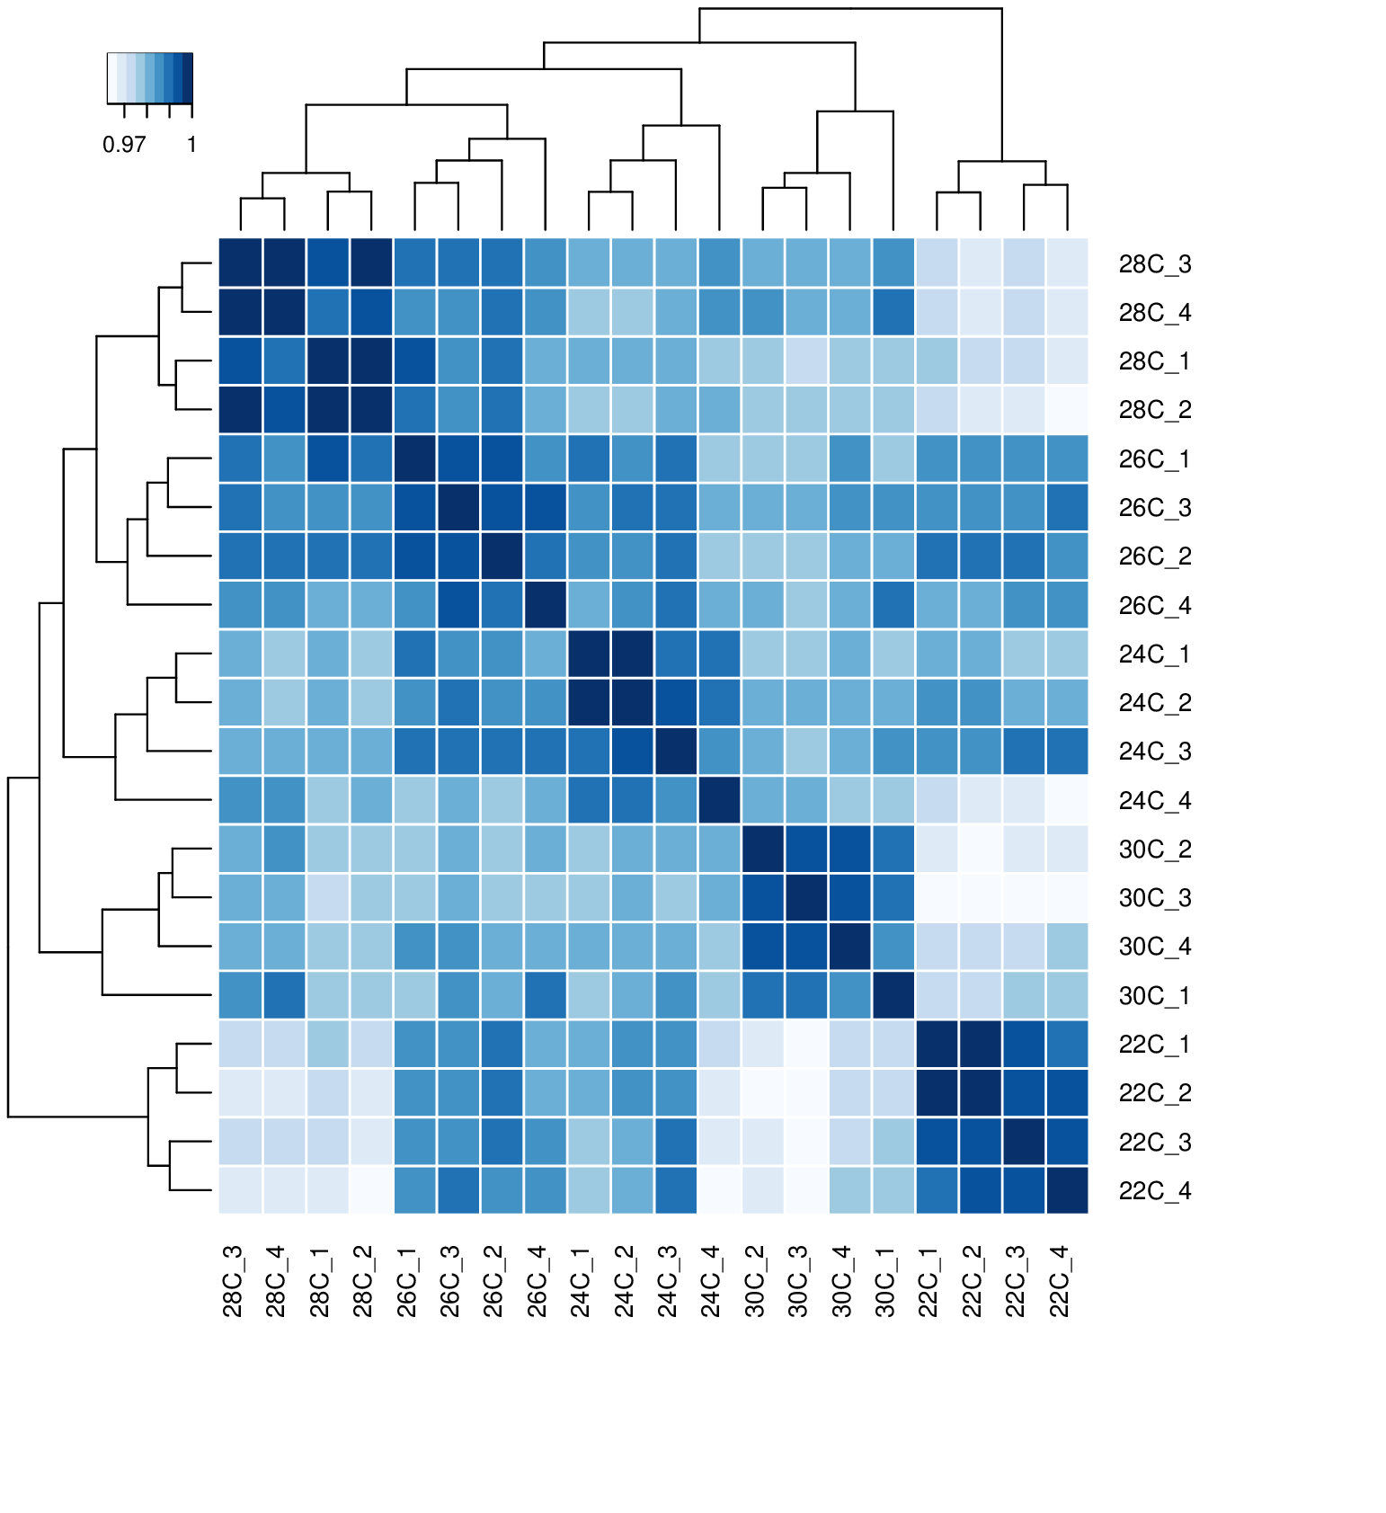

Fig. S8: Heatmap of Pearson correlation coefficients of the RSP50 RNA-seq read counts showing a distinct separation between all tested temperatures.

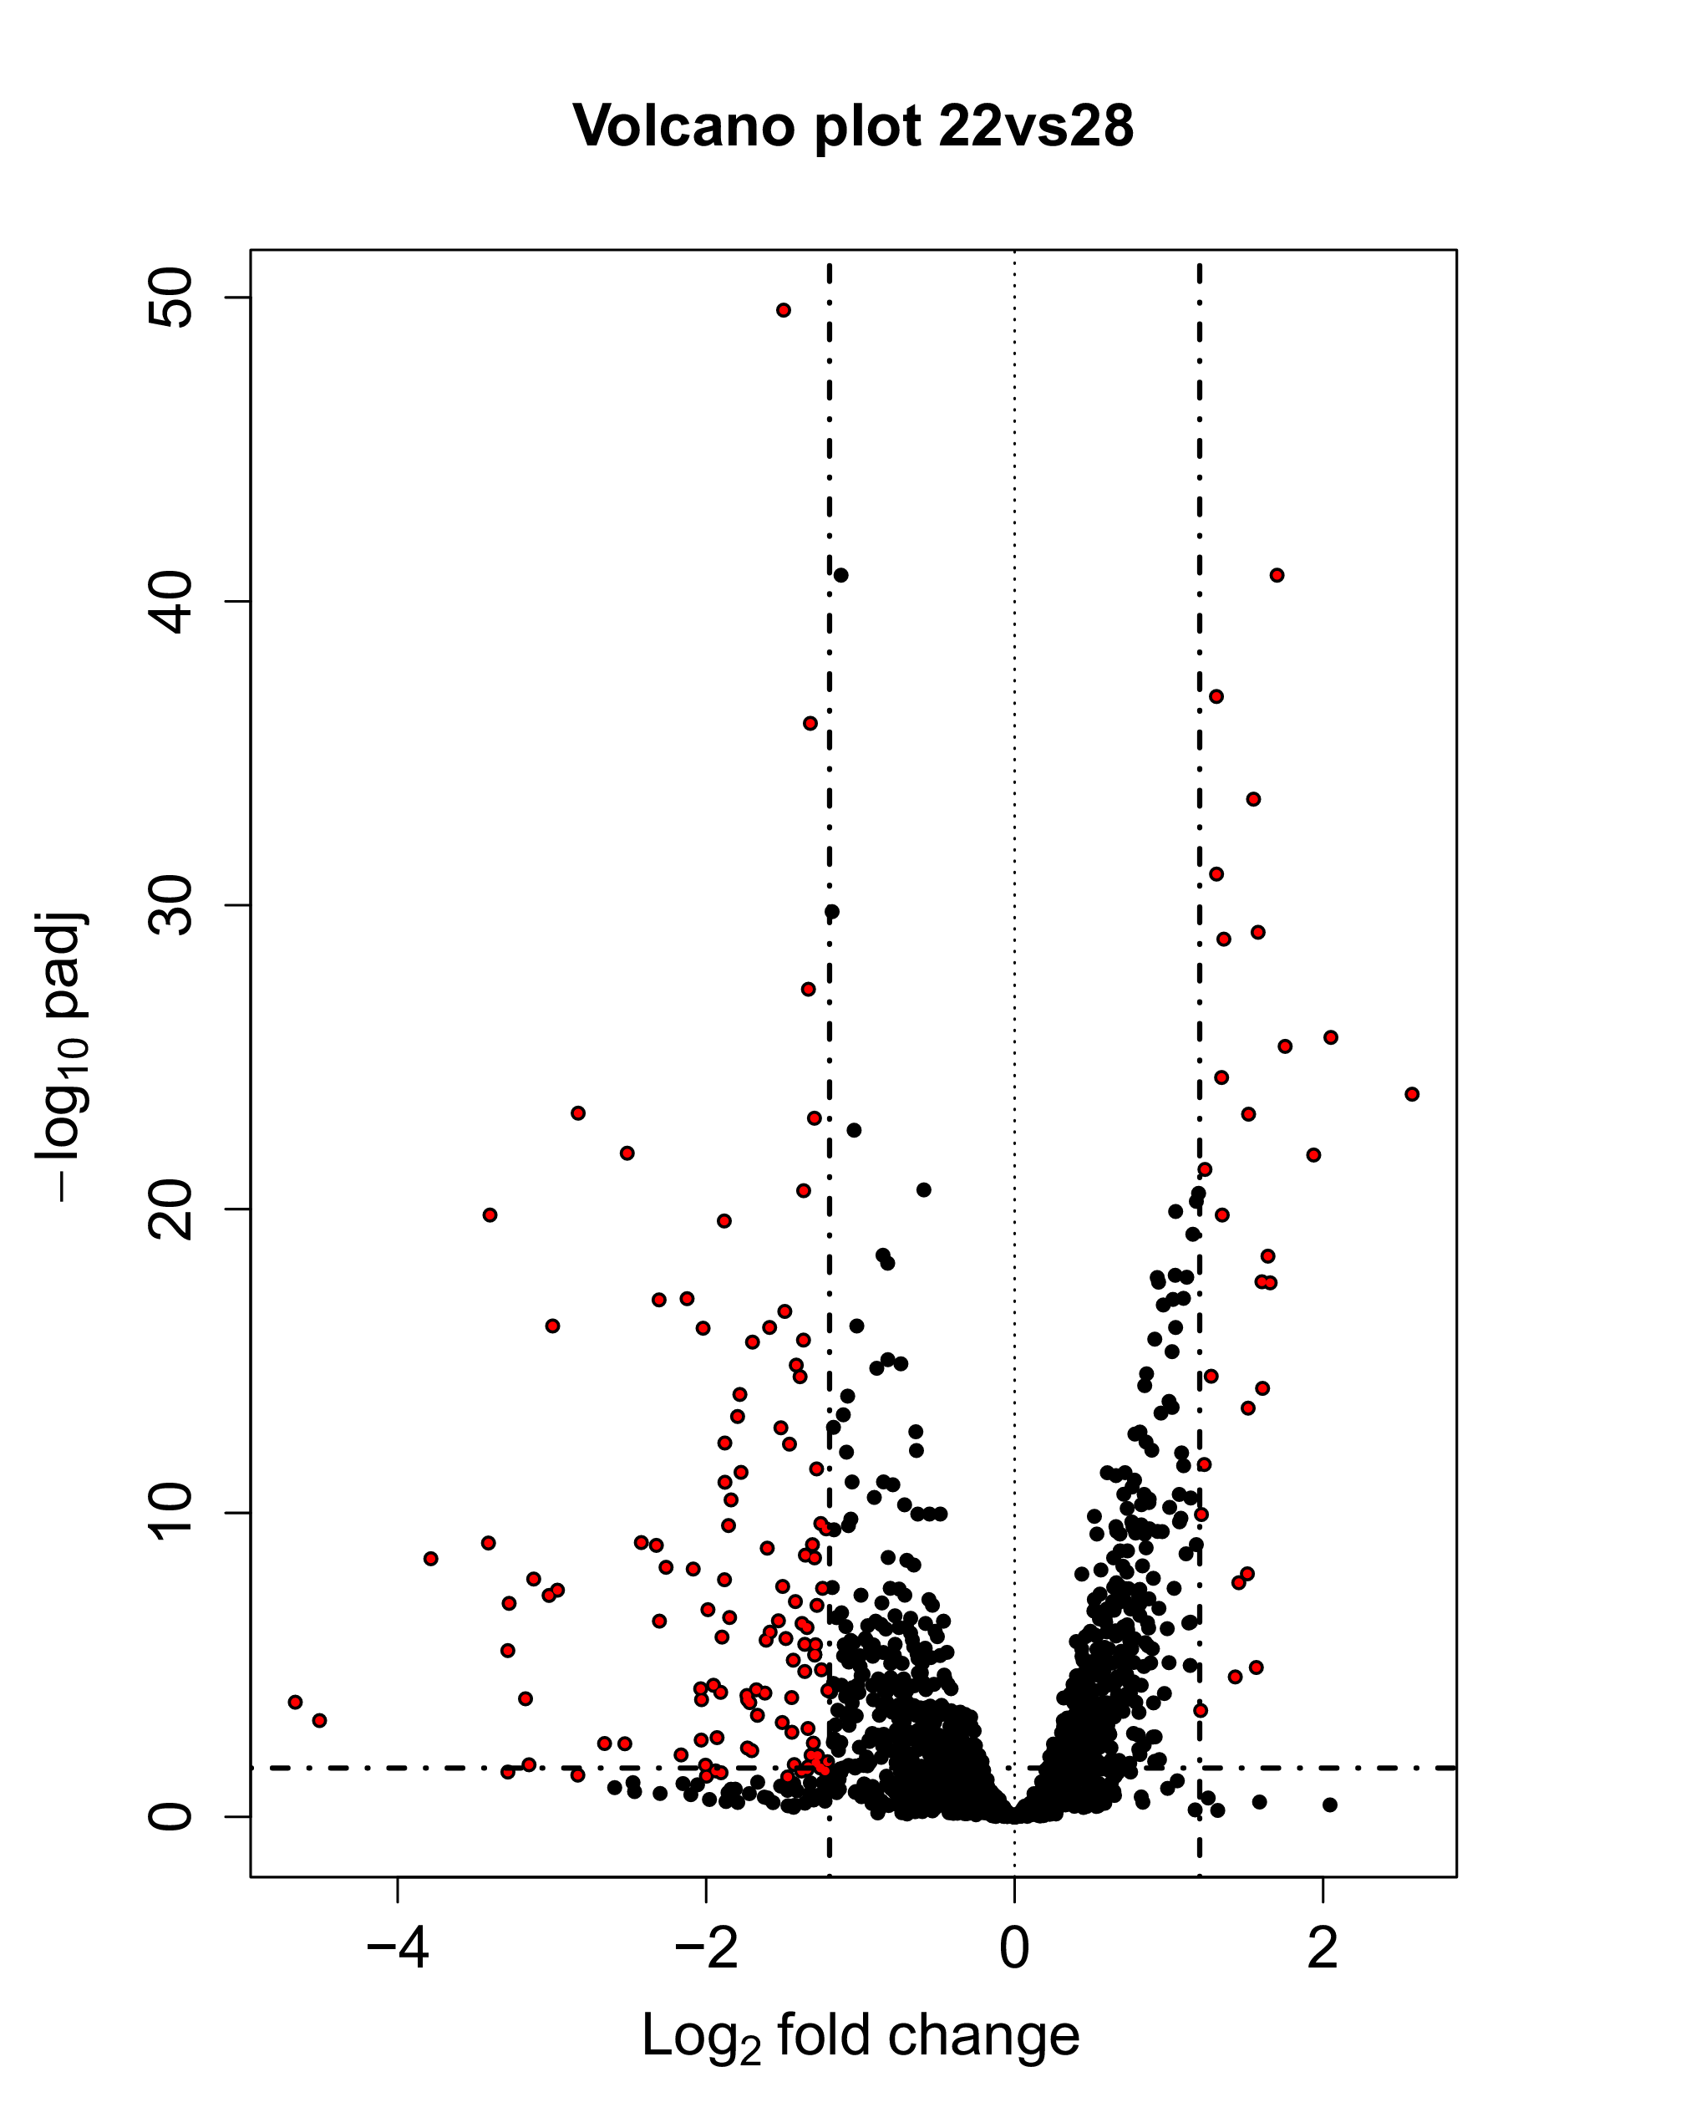
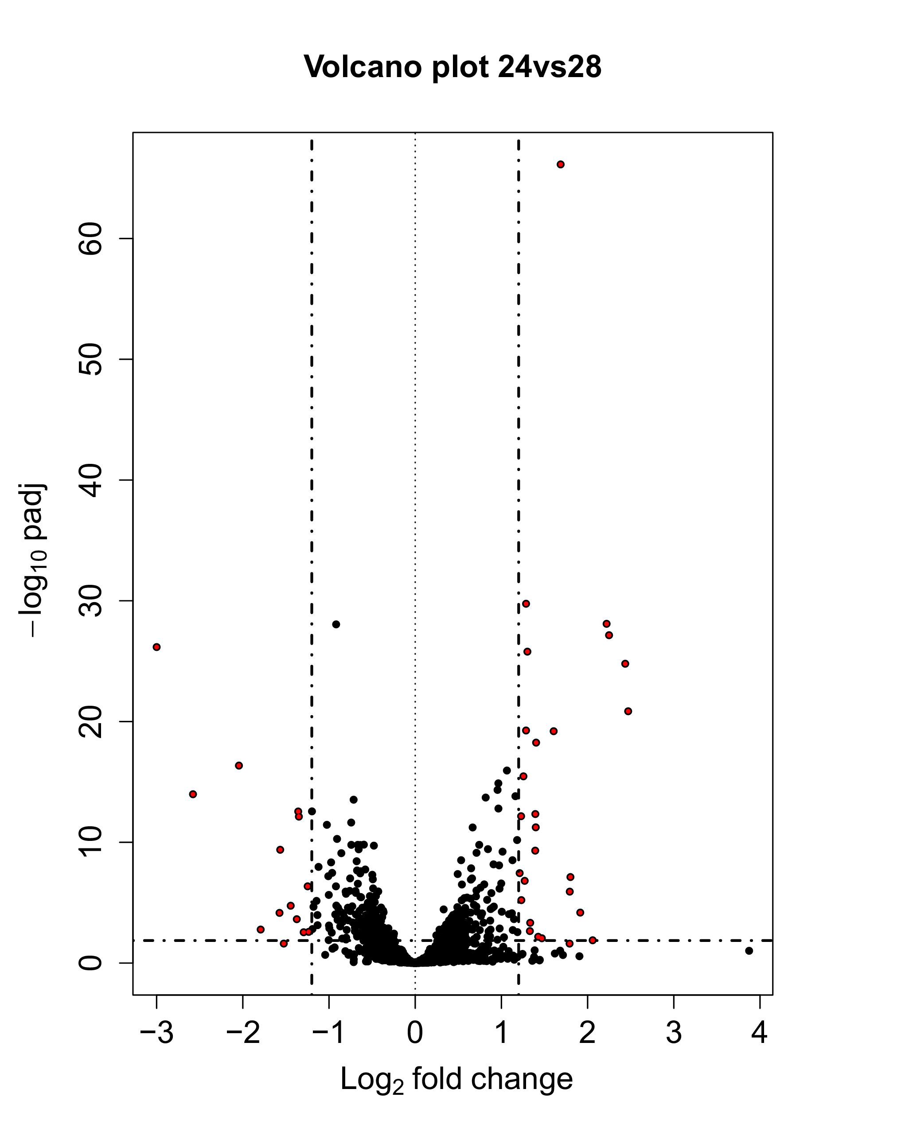
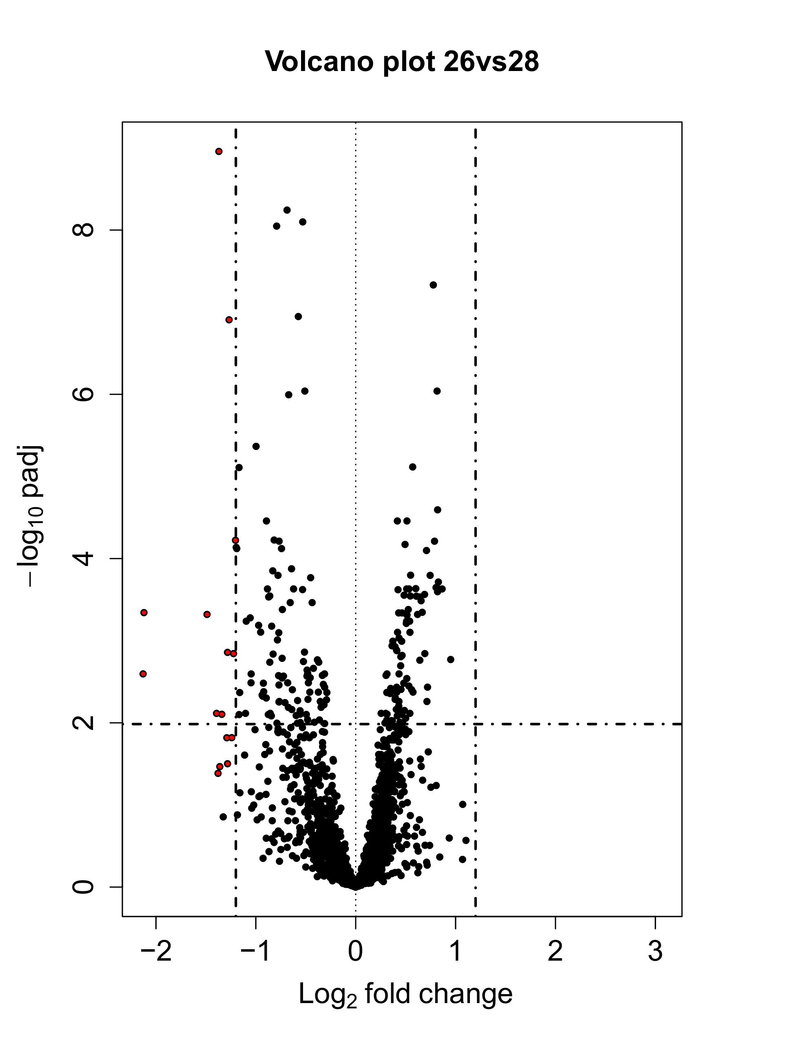
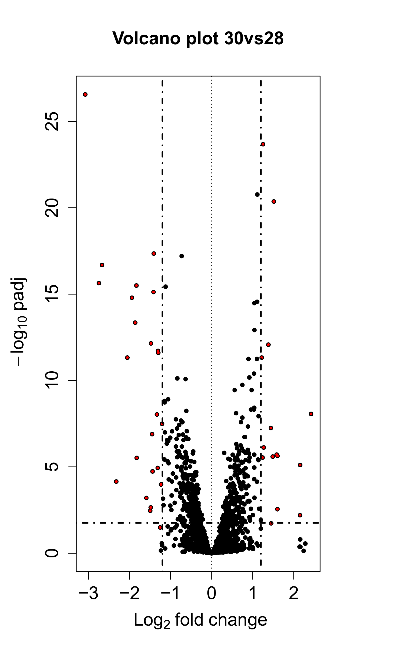

Fig. S9: Volcano plots illustrating differential gene expression in the 22°C, 24°C, 26°C, and 30°C samples against the 28°C sample.

